Visit Cambridge Partnerships
The information below appears on the website for tourists considering visiting the city of Cambridge and its surrounding area. The organisation is a DMO called Visit Cambridge. As you will see, the organisation has a number of partners and the tourism businesses which appear on the site have paid a membership fee to have their adverts appear.
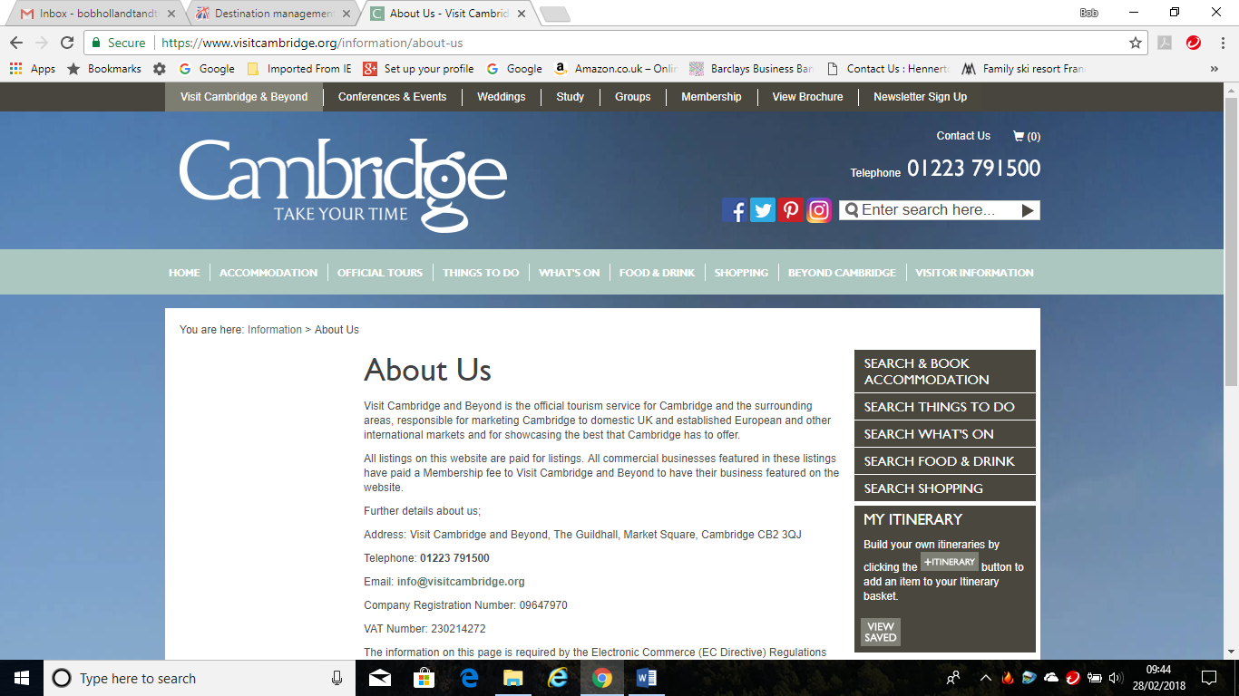

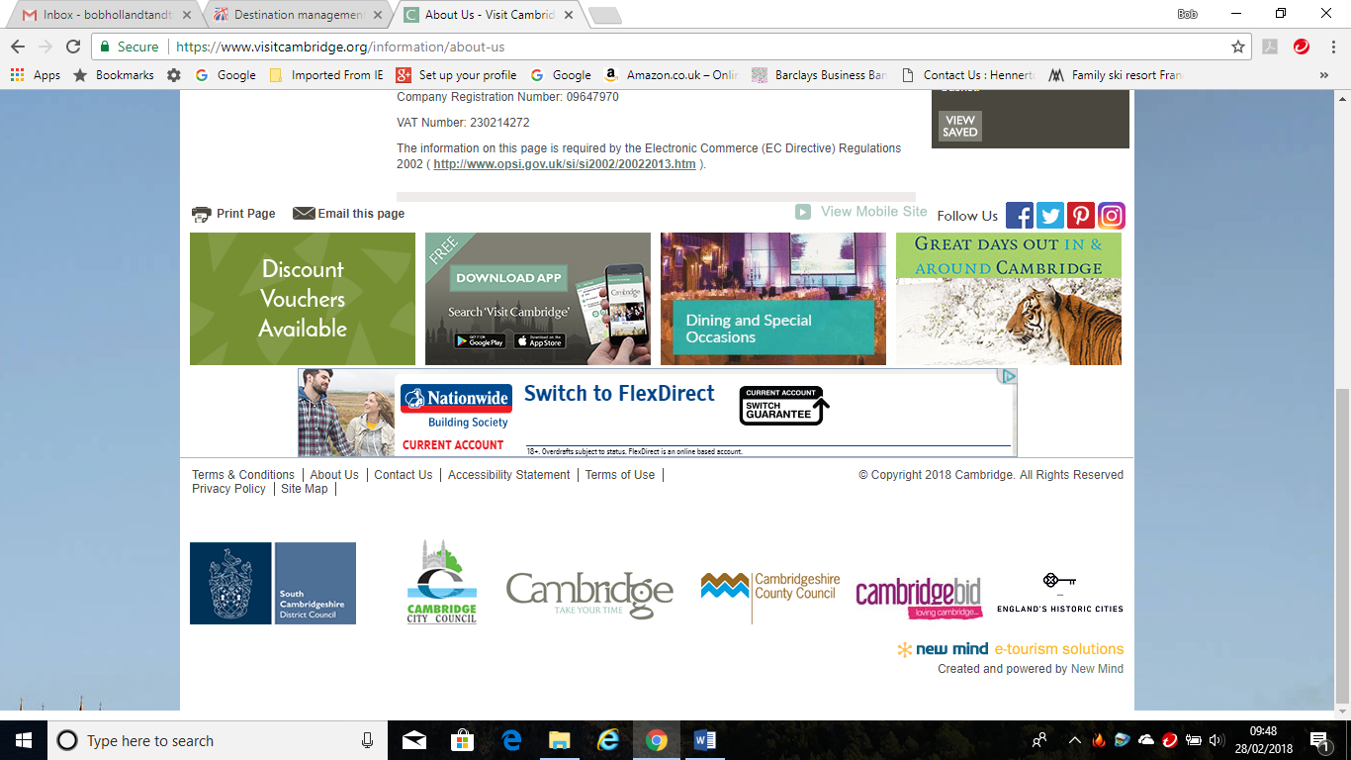
The advertisements below appear on a loop on the site.

One of the advertisements is for ‘Great Days Out In & Around Cambridge’.
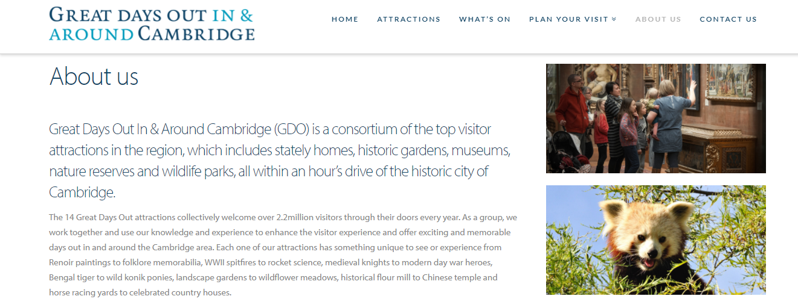
As you will see, ‘Great Days Out In & Around Cambridge’ is a group of 14 attractions which have formed a partnership and are using joint-marketing through the Visit Cambridge website, for which they have paid a membership fee to advertise.
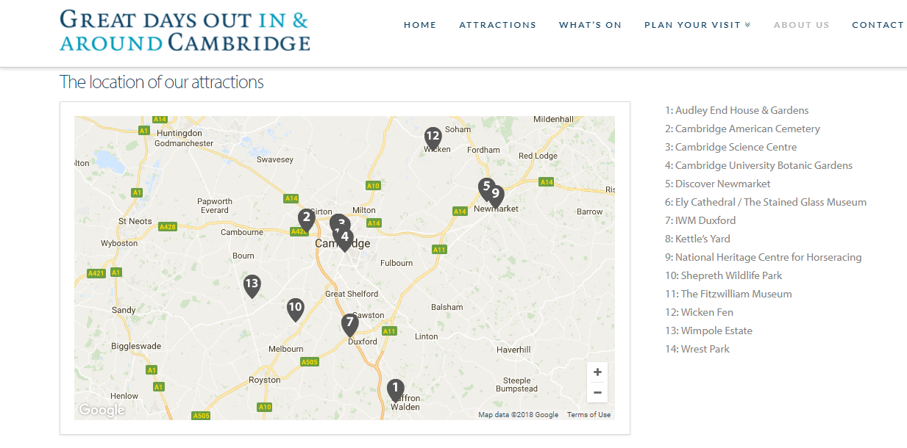
The 14 attractions are varied and show the wide range of attractions in the UK which appeal to different types of visitor. For example:
- Wicken Fen is a wildlife reserve owned by the National Trust
- The Cambridge Science Centre is supported by a range of commercial companies amongst other organisations
- Ely Cathedral is an historic attraction which is part of the Church of England
- Discover Newmarket is mainly concerned with providing guided tours of the town and surrounding area
- The American Cemetery is a large graveyard where the bodies of thousands of American soldiers, killed in the Second World War, are buried.
Most of these attractions are not competing directly with each other. It is quite possible to visit two or three of the attractions in one day. Managers of the attractions feel that by forming the partnership and marketing their products and services through the Visit Cambridge website, they are likely to obtain more visitors.
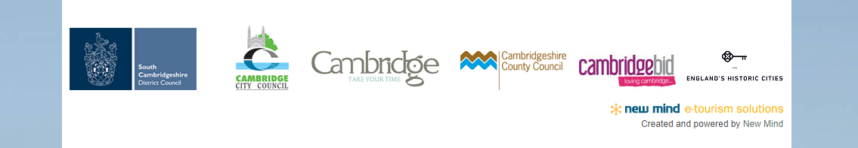
As seen from the section of the website above, the Visit Cambridge DMO has been set up by a number of key partners which are:
South Cambridgeshire District Council – a local authority serving the area mainly to the south of Cambridge
Cambridge City Council – a local authority serving the city of Cambridge itself
Cambridgeshire County Council – responsible for the whole county with a wider responsibility
Cambridge Business Improvement District (BID) – a group of over 1,000 businesses such as shops, bars, cafes and attractions which are located within the city centre of Cambridge
England’s Historic Cities – a joint-marketing of 13 historic cities in England, of which Cambridge is one
Information about Cambridge BID is shown below.
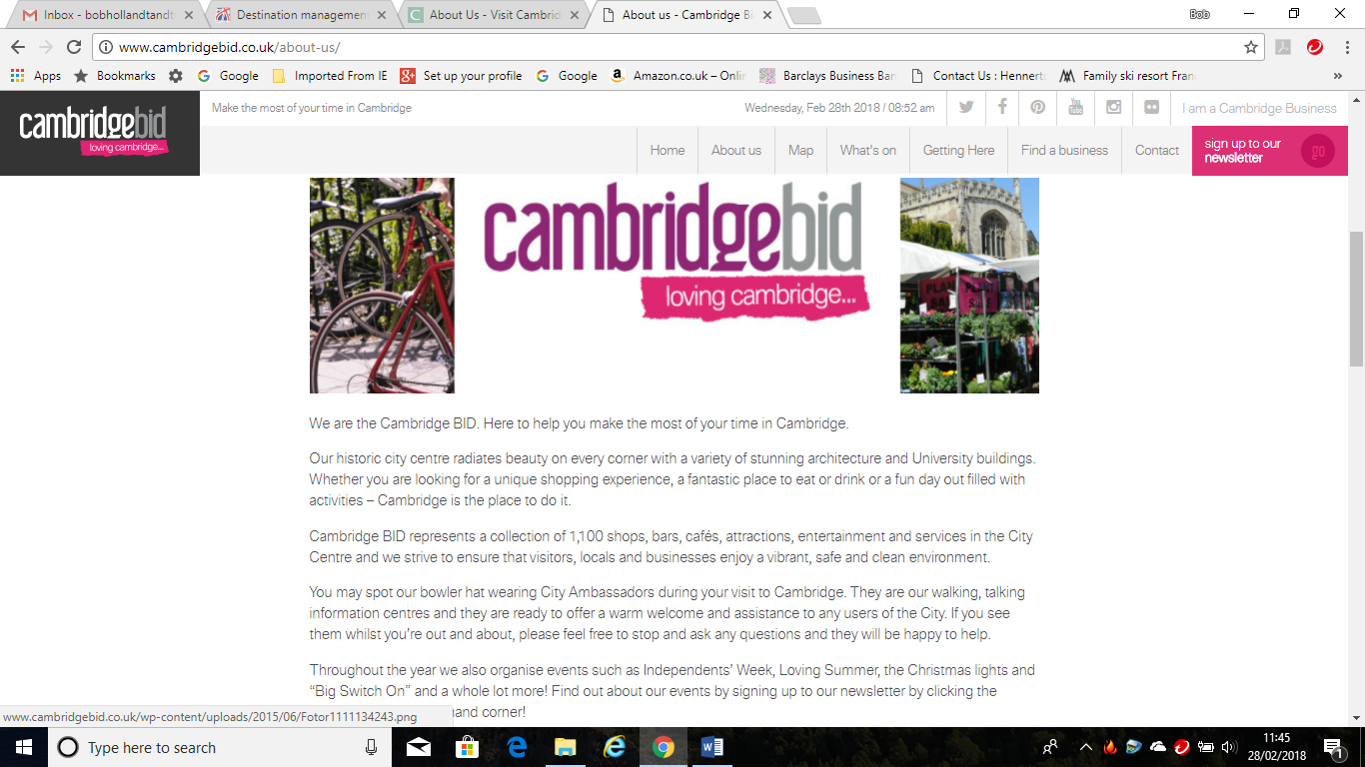

Conclusions
The information above should show you that partnerships between tourism organisations can be very complex and that there can be relationships between all sorts of organisations involved in tourism in some way. The Cambridge example shows that there are ‘partnerships within partnerships’ and that it is not always easy to put tourism organisations into simple groups.

Activity 1

- What do the initials DMO stand for?

- Explain what is the purpose of Visit Cambridge and Beyond?

- Summarise the products and services provided by the Great Days Out In & Around Cambridge consortium.

- Suggest why the American Cemetery should be seen as a tourist attraction.

- Explain the role of the people wearing bowler hats.

Activity 2
There are 13 cities in the English Historic Cities group. Can you identify them from the word search below?

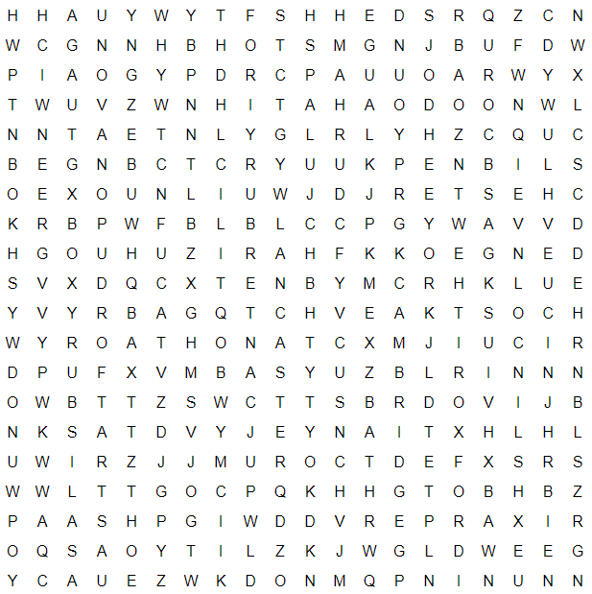

Salisbury
Stratford-upon-avon
Carlisle
Oxford
Bath
Canterbury
Lincoln
Chester
Lancaster
York
Greenwich
Durham
Cambridge

