Transport Development
All tourism organisations which offer transport for visitors to travel to and within a destination can provide new products and services which can add to the appeal of a destination.

Activity 1
Move the transport organisations in the table below so that they match the possible development which might appeal to different types of tourist.
Transport provider | Possible development
Mountain bus service | Timetable for stops near major attractions along two rivers within the destination.
Cycle hire company | New schedule to the destination from Athens, Rome and Madrid.
Bus company | New late night fixed fares to hotels from the city centre.
Train company | New Park and Ride from two locations outside of the city destination.
Car hire company | Schedule of stops near major walking routes in the mornings and evenings.
Airline | New timetable providing improved services to nearby towns with historic attractions.
Taxi company | Discounted weekend rates with free child seats included.
Water taxi | Free maps to show new 10-mile and 20-mile routes around the destination.

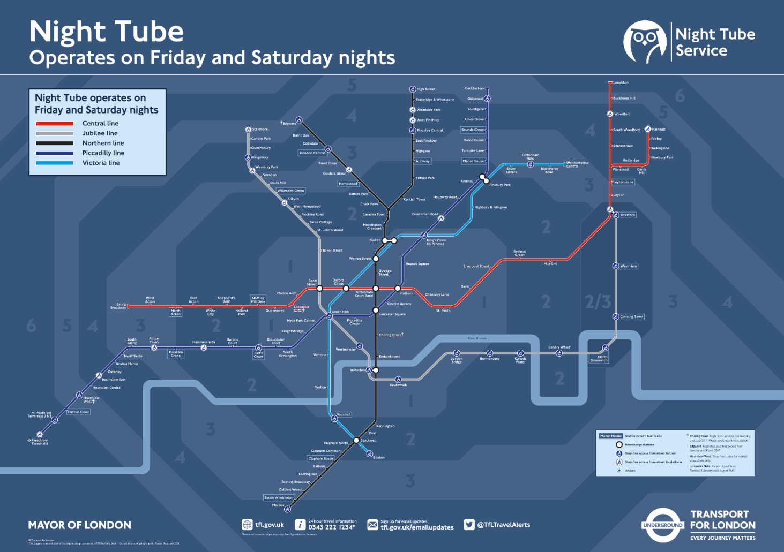

Activity 2
The map above shows the network of routes operated by Transport for London on the underground system throughout the night on Fridays and Saturdays.
Explain how this can add to the appeal of London as a tourist destination.

