Adding to tourist appeal
Study the photograph below of a beach below a cliff in the south of England. There is a car park on higher ground behind the beach and there are some steps down to the beach.
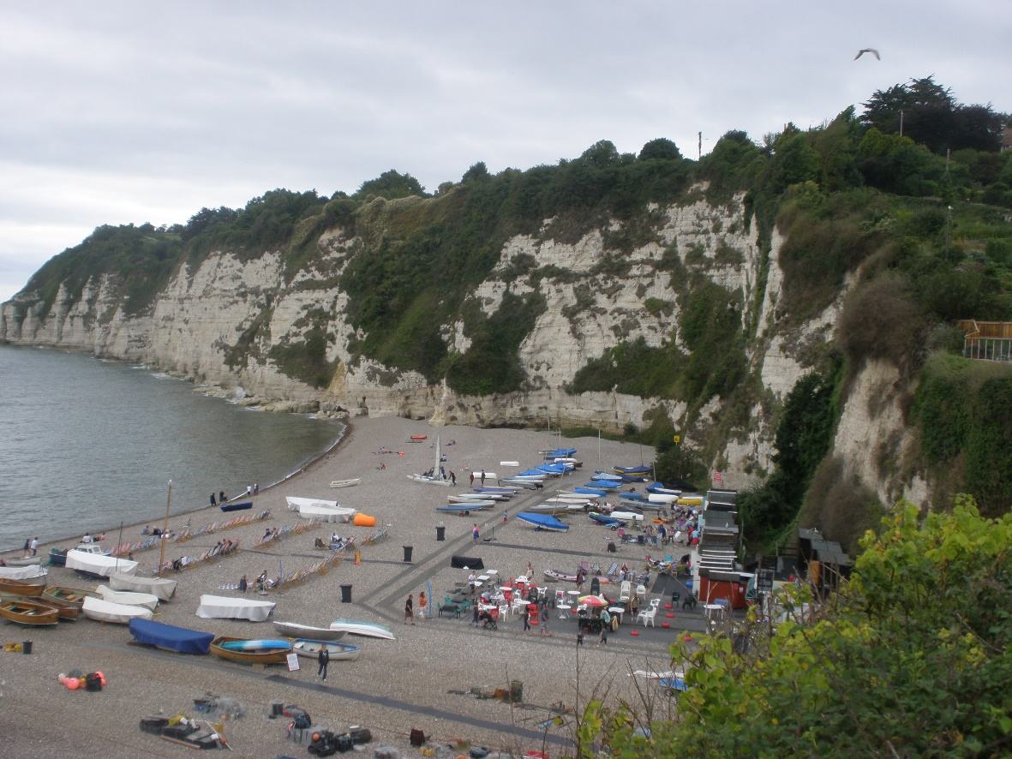

How do you think that the facilities on the beach and the area near the beach can be developed to make it more appealing to different types of tourist?
Make 5 suggestions.

