Word search

Activity 1
See how many words and terms associated with tourism development you can spot in the word search below.

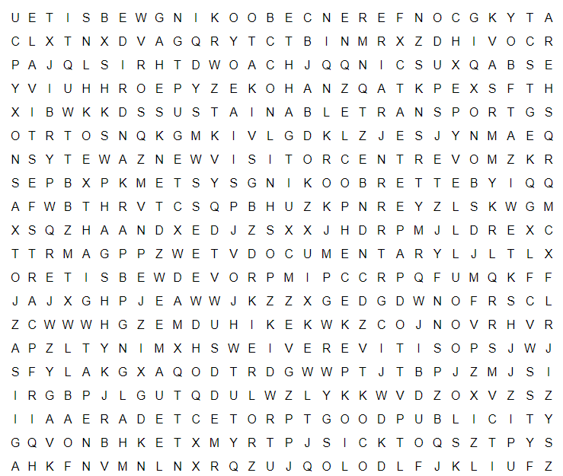

New visitor centre
Positive reviews
Improved website
Park and Ride
Better booking system
Protected area
TV documentary
Sustainable transport
Good publicity
Arts festival
Conference booking website

Activity 2
When you have completed the word search choose 6 of the terms and suggest how each of them can help tourism development in a destination.
Term | How it can help tourism development

