Review sites
A review site such as TripAdvisor, is a website upon which reviews can be posted. You will need to appreciate that these reviews can be either positive or negative and that rating and review sites influence consumer shopping behaviour. This means that review sites can influence how tourists will decide to spend their money.

Activity 1

Scenario
I am a tourist who wants to go to Australia backpacking. Where do I begin my research in order to plan my trip?
I think I will look at Lonely Planet and then see if I can find out further information from TripAdvisor.
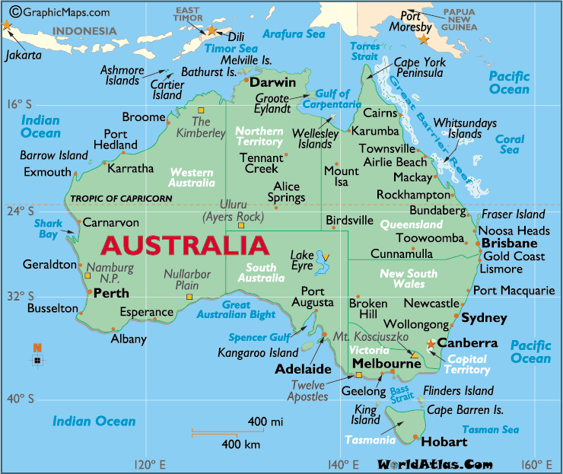
I am going to fly to Sydney Australia, and travel around Sydney for the first few weeks. I wonder what backpacker hostels will be good to stay in?
Then I intend travelling up to the Gold Coast, I have heard it’s good. I will check out fellow travellers’ reviews to help me find out the best ways of travelling up to the Gold Coast and where to stay.
Before I leave Australia I must visit Phillip Island, Melbourne. I want to see the Penguin Parade; it’s a must for me! I need to find out how to get there, where to stay and what the best time to visit is. I bet other tourists have left reviews on TripAdvisor.
Over to you ...
You are the tourist – what can you find out?

Activity 2
Choose one of the following UK coastal tourism destinations
- Brighton
- Blackpool
- Barmouth
Using TripAdvisor and or other review sites create a PowerPoint presentation that will tell tourists 10 things they need to know about the destination. This can include positive and negative information found on the review sites used.

