Destination Marketing
You are going to be investigating how destination marketing departments try to get the attention of target audiences by using slogans, packaging design, celebrity endorsements and general media exposure.
Many tourists go online to discover places they are going to visit, book hotel rooms and transportation. They plan trips and share their emotions and memories with friends. Destination marketing is vital in order for destinations to stay competitive.

Activity 1
How does a destination’s website influence a tourist’s decision? – It’s all about the way it promotes itself!
Investigate the website of a UK tourism destination.
Look closely at how the website of your chosen destination has been designed.
Identify words, phrases and images used to promote the destination.
Words | Phrases | Images

Explain why the words, phrases and images are effective at promoting the destination.

Activity 2
Tour operators
You need understand that tour operators create websites that promote the holidays to destinations they are selling. Tourists can log on to their internet browser and locate their chosen destination from the comfort of their own home.
Can you locate the names of the following tour operators in the word search below?
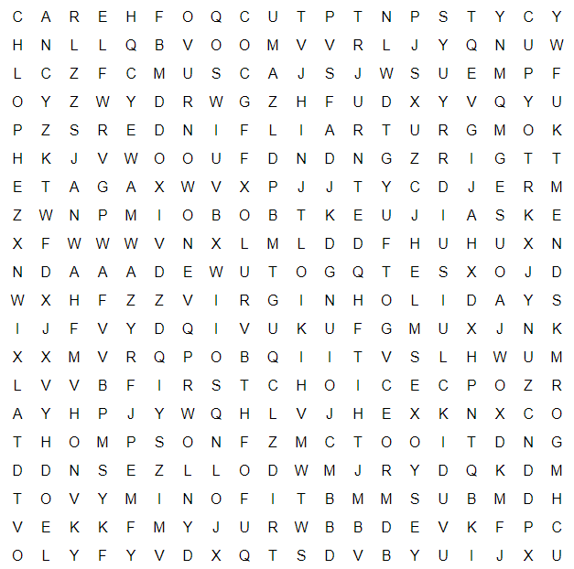

Trailfinders
Exodus
First choice
British Airways Holidays
Kuoni
Thompson
Virgin Holidays
Tui

Activity 3








Choose two or more of the tour operators found in the images above.
Look them up on the Internet – what do you think? Good? Bad? Give reasons to support your answer, try to use alternative phrases to ‘eye catching’.
Name of tour operator ---------------------------------
I think the images of the website are good/bad because -------------------------------------------------------------------------------------------------------------------------------------------------------------------------------------------------------------------------------------------------------------------------------------------------
Now, can you answer the following questions?
What is the main target market? (That is, what main tourist type is the tour operator aiming at? e.g. Families? Couples? Groups? Older generation?)
------------------------------------------------------------------------------------------------------------------------------------------------------------------------------------------------------------------------------------------------------------------------------------------------------------------------------------------------------------------------------
What words and images can you find that support your thoughts on the chosen target market?
Why do you think words and images are important?
Many tourists go online to discover places they are going to visit, book hotel rooms and transportation. They plan trips and share their emotions and memories with friends. Destination marketing is vital in order for destinations to stay competitive.

Activity 4
You are a tour operator who is researching a destination for tourists to visit.
Choose a UK destination you would like to research. Using the Internet, research your destination to find transportation around the destination, suitable accommodation, and things to do while tourists are there.
Prepare a leaflet to promote your chosen destination that will encourage tourists to visit. Think about your target market.

