Built attractions
Built attractions fall into two groups.

Purpose-built attractions
These are places which have been built specifically to attract tourists. Theme parks, amusement parks, aquariums etc. are all examples of purpose-built attractions. In most cases tourists will have to pay an entry charge since the attractions will be part of the private sector.

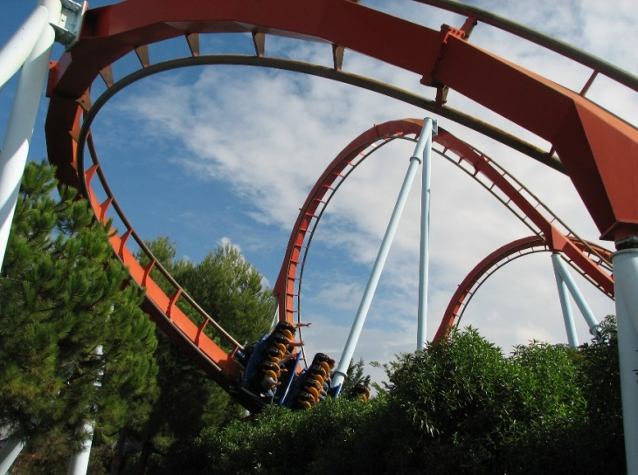
Activity 1
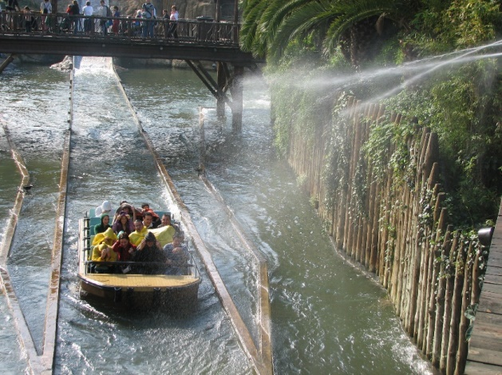
Study the images below.
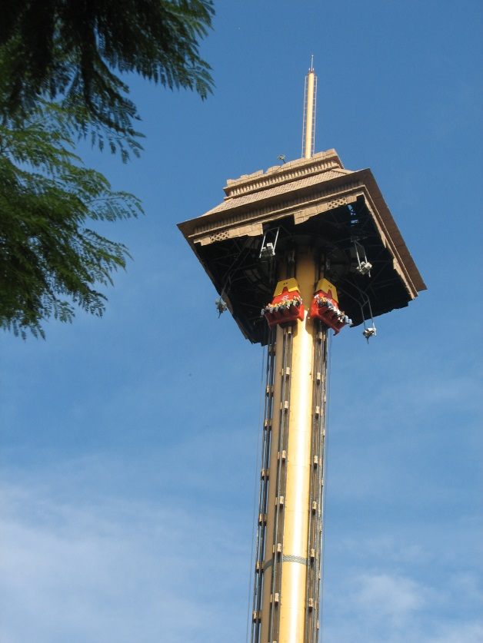
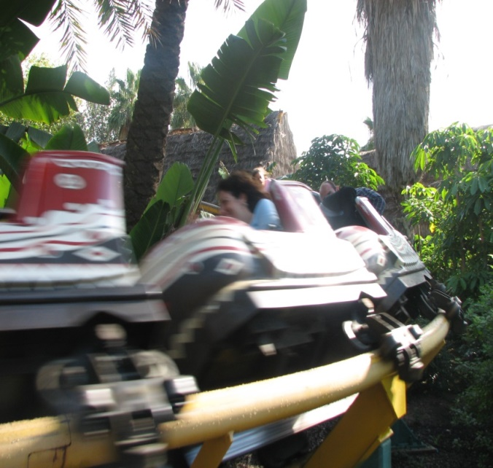

Using the images, explain why many younger tourists enjoy visiting theme parks.

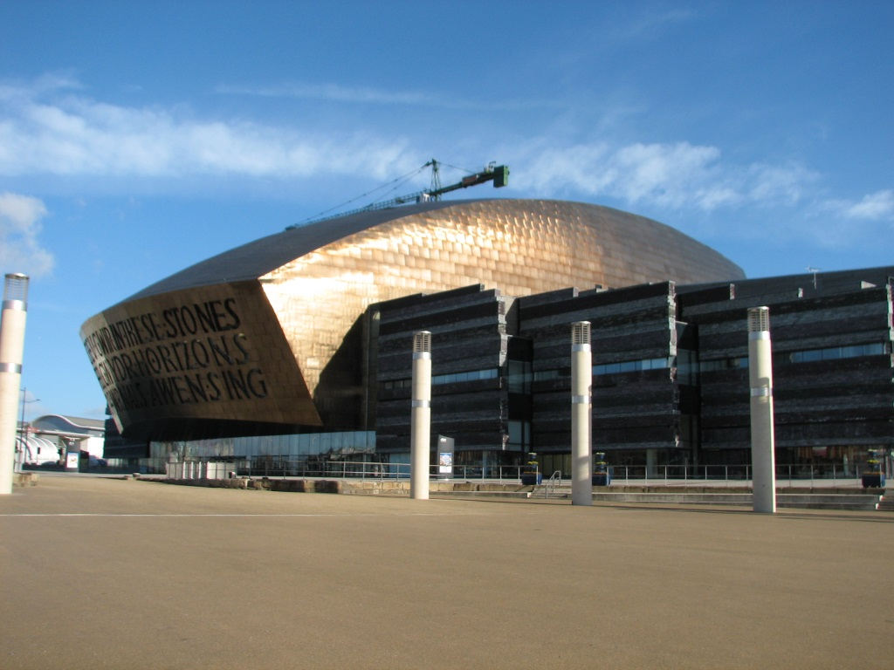
Purpose-built attractions also include museums and art galleries. These buildings may be free entry or, in some cases charge an entry fee. They allow visitors to see important works of art or see exhibits which show the culture and history of the locality. Some theatres, such as the Wales Millennium Centre fall into this category.

Activity 2
Investigate the products and services provided by the Millennium Centre and explain why tourists visiting Cardiff Bay should spend time in the centre.
……………………………………………………………………………………………………………………………
……………………………………………………………………………………………………………………………
……………………………………………………………………………………………………………………………
……………………………………………………………………………………………………………………………
……………………………………………………………………………………………………………………………
……………………………………………………………………………………………………………………………

Also, some sports stadiums can be classed as built attractions, especially those which offer tours of the facilities. The Principality Stadium would be an example.

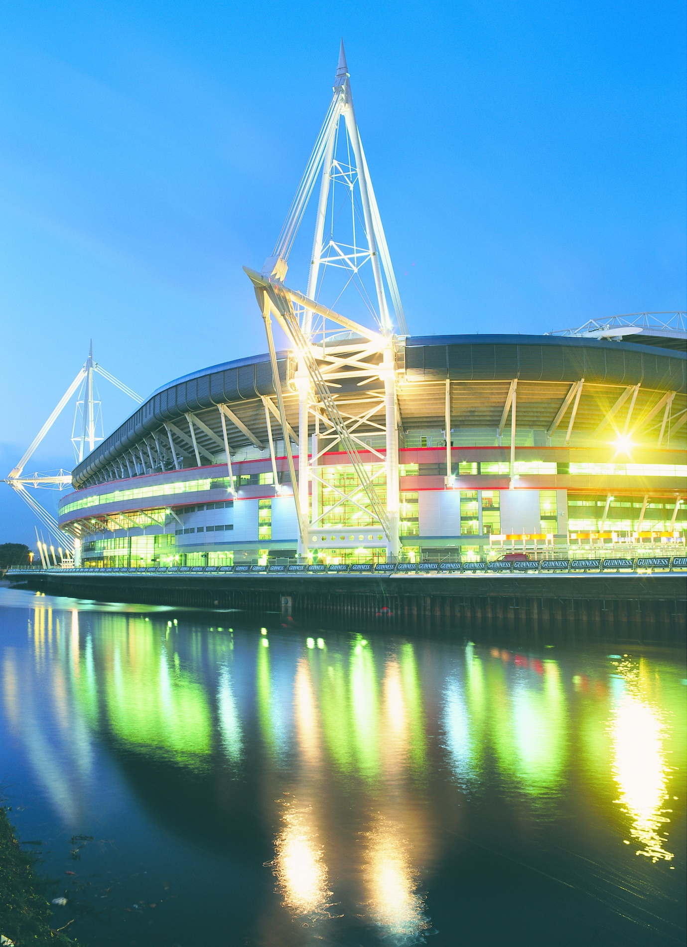

Attractions over time
The second group of built attractions are those which have become attractions over time. Castles, churches, cathedrals and some industrial buildings were never built as tourist attractions, but today some receive thousands of visitors each year.
Examples in Wales include Big Pit, Conway Castle and St David’s Cathedral in Pembrokeshire.
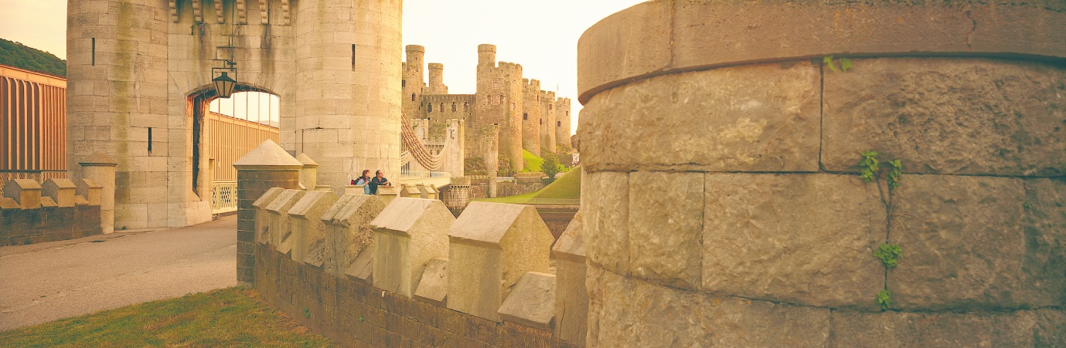

Activity 3
- Name three other churches or cathedrals which have become major tourist attractions.
……………………………………………….......................................................................…
…………………………………….......................................................................……………
……………………………........................................................................……………………
- Name three other castles which have become popular tourist attractions.
………………………………….........................................................................……………..
…………………….........................................................................…………………………..
…………………..........................................................................…………………………….
- Name three other industrial sites which have become tourist attractions.
…………………………………………..........................................................................…….
…………………………………...........................................................................……………
……………………….............................................................................…………………….

