Exchange Rates
When tourists travel from one country to another, they have to change money into the currency of the country they are visiting. So, when UK tourists visit France or Spain they have to buy euros. Likewise, when tourists from the USA visit the UK, they have to buy British pounds.
Also, when tourists use credit cards while they are abroad on holiday, what they spend when they are on holiday is converted back into British pounds when they receive their bill.
An example is shown below. The credit card was used to buy a number of goods and services in France in Euros. These amounts were then converted into British pounds by the credit card company.
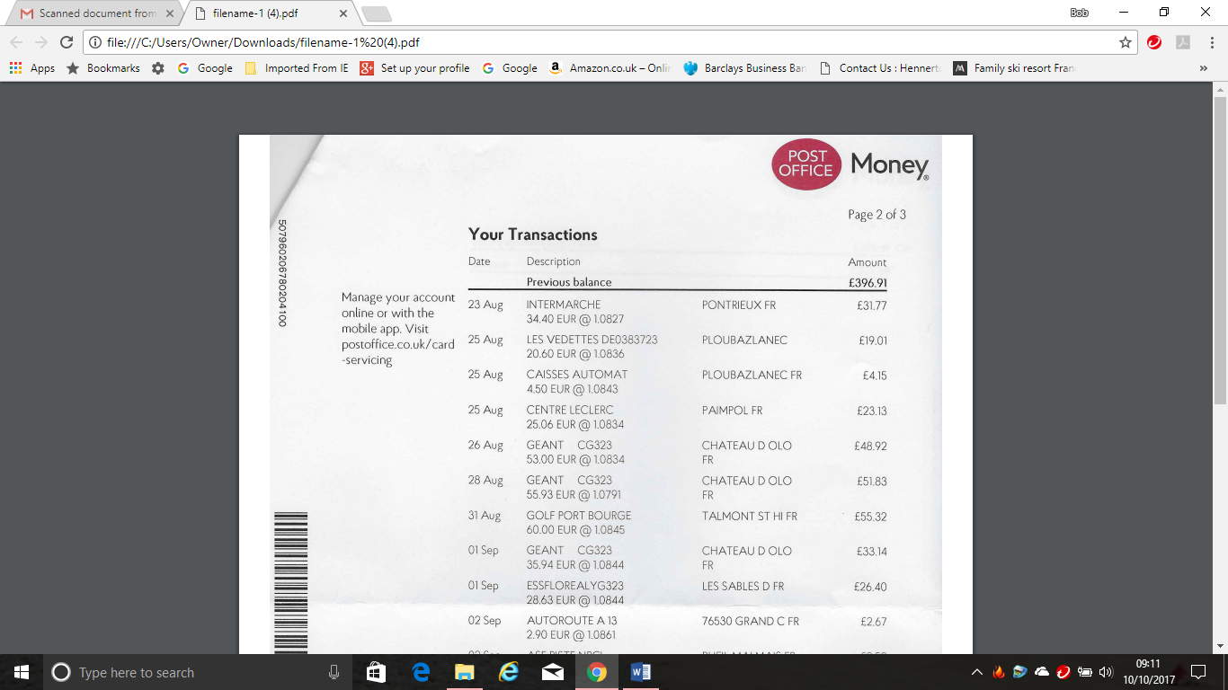
You will see that over the period in which the card was used the exchange rate between Euros and British pounds changed. For example, on August 28th, the rate was 1.0791 Euros and on August 31st the rate was 1.0845.
The rates of exchange between different currencies are continually changing, depending on economic and political conditions. These changes affect tourists and tourism organisations.
Exchange rates between different currencies can change a lot over a period of time, such as two or three years and these changes can have a big impact. Sometimes, the terms ‘strong pound’ and ‘weak pound’ are used.
A ‘strong pound’ means that tourists can buy a lot of foreign currency when they go abroad, making their holiday cheaper. A ‘weak pound’ means that less currency can be bought, making things more expensive for UK tourists abroad.
The table below shows some of the issues.
Strong pound | Weak Pound
Impacts for UK tourists travelling abroad
- Cost of holidays and flights might be cheaper  - Other costs such as eating out, attractions etc. will be cheaper  - More UK tourists likely to travel overseas | - Costs of flights and holidays become more expensive  - Eating out etc. becomes more expensive  - Less UK tourists likely to travel overseas
Impacts for overseas tourists travelling to the UK
- It will cost more to visit the UK  - Eating out, attractions etc. become more expensive  - Less overseas visitors likely to visit the UK | - It will cost less to visit the UK  - Eating out etc. becomes less expensive  - More overseas visitors likely to visit the UK
Impacts for tourism organisations operating outside the UK
- Likely to have more customers  - Increased business  - Become more profitable | - Likely to have less customers  - Decreased business  - Likely to become less profitable
Impacts for tourism organisations operating within the UK
- Might have less customers as people are travelling abroad instead  - Less business and less profitable | - Likely to have more customers from the UK because they cannot afford to travel abroad  - Likely to have more customers from overseas  - Likely to be more profitable

Activity 1
Explain how changing currency exchange rates might have an impact on the following businesses:
- A small hotel in a UK seaside resort.

- A UK based tour operator taking small groups of tourists to Europe.

- A large attraction.

When buying foreign money to spend abroad, tourists need to have some idea of what they are spending and how much things are costing. So, calculating how much a foreign currency is worth is important.
Let’s assume that at a moment in time £1 has an exchange rate of $1.35 and 1.12 Euros.
To change British money into foreign money the following formula is used:
Foreign currency = British currency x Exchange rate
So, given the exchange rates above:
For £100 a tourist would receive
$135 (£100 x 1.35) and 112 Euros (£100 x 1.12)
Let’s say that a year beforehand the exchange rates had been $1.47 and 1.29 Euros. If this were the case, the UK tourist would be worse off changing money than they had been a year ago and items bought when abroad would be more expensive.

Activity 2
Research currency converter websites to see what today’s exchange rates are compared to the ones given above.

