Objectives Word Search

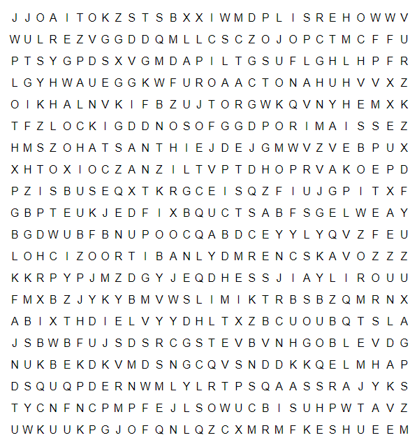
Survival
Objectives
Business
Organisation
Objectives
Aims
Targets
Goals
Smart
Scale
Tourism

Activity 1
Can you find all of the words above in the word search?

Activity 2
Tourism businesses often set SMART objectives. Can you find out what the letters stand for?
S -
M -
A -
R -
T -

Activity 3
‘What are business objectives?’
Can you write a paragraph or two explaining what you mean by business objectives, using as many of the words in the word search as possible?

