Transport Organisations
Transportation is very important to the tourism industry as it allows tourists to access where they want to go; it also provides many wide and varied jobs for people. Transport can be by air, land or sea. There are many organisations operating within the UK which vary in size and scale from small to medium to large to international.

Activity 1
Who are we?
Below are a number of well known logos of various transport providers operating from and within the UK. Can you match the logo to the correct type of transport provider?
airline
Cruise ship
taxi
ferry
coach
train

Logo | Transport provider type
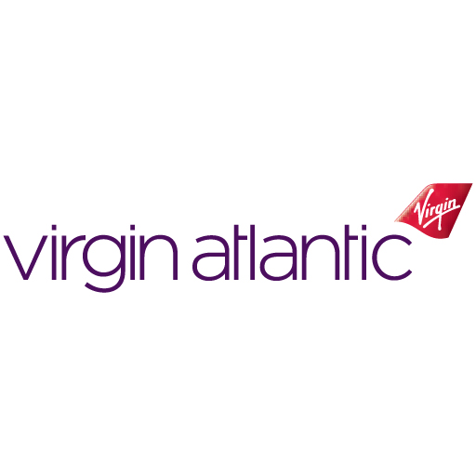

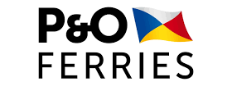
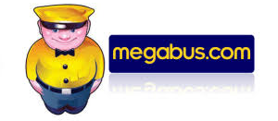
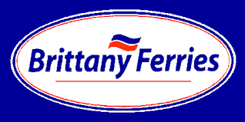

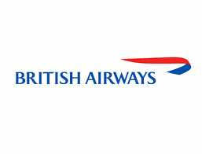
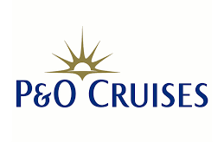




Activity 2 – What form of ownership?
There are many transport providers operating within the UK which vary in size and scale; from small and medium scale to large, international scale providers. This means that the transport providers have different forms of business ownerships.
Can you identify the correct form of ownership for the transport providers below?
You may need to conduct some research.
Not-for-profit
Partnership
Sole Trader
Private Limited Company Ltd
Public Limited Company PLC

Transport Provider | Ownership
Stena Line – a family owned company that does not sell shares on the stock market
Carla’s Cabs – a small taxi firm owned and operated by a lady called Carla Freeman
Thomas Coaches – a family run business with a fleet of 20 coaches. There are a number of family members involved who have bought shares in the company.
Arriva – a leading pan-European public transport operator with over 60,000 employees and operations across 14 European countries.
J&J Mini Bus Hire – two men, Joe and Jamhal own and run a successful minibus hire company
TFD – Transport for Dartmoor, a group of volunteers operate a mini bus service that has a trailer attached to the mini bus that can carry cycles from stops along the route.

