Pedestrian counts
Pedestrian counts can be used to obtain data about the customer experience in two ways.
Firstly, they can be used to see how long it takes to queue for an attraction, ride or for refreshments. When you visit your chosen organisation, carefully and quietly, choose a person joining a queue and time how long it takes them to get to the front of the queue or get served. Do this 5 times and see what the average time taken is. You could come back later and see if the average time has changed.
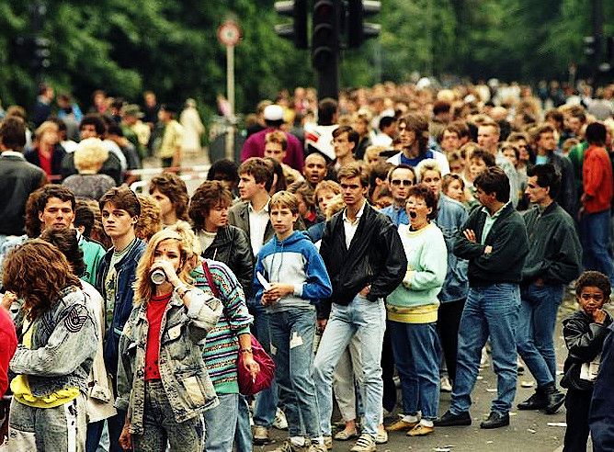
Secondly, draw an imaginary line across somewhere where people walk. In one minute, count the number of people that walk across your imaginary line. Do this 5 times and work out the average. Then repeat the exercise in another location, or share results with your classmates. It might well be that the customer experience is not as good in crowded areas where there are too many people.

Activity
Develop a suitable table to record your results.

